Hard VBA Homework solution image

Sheet 1: Year 2016

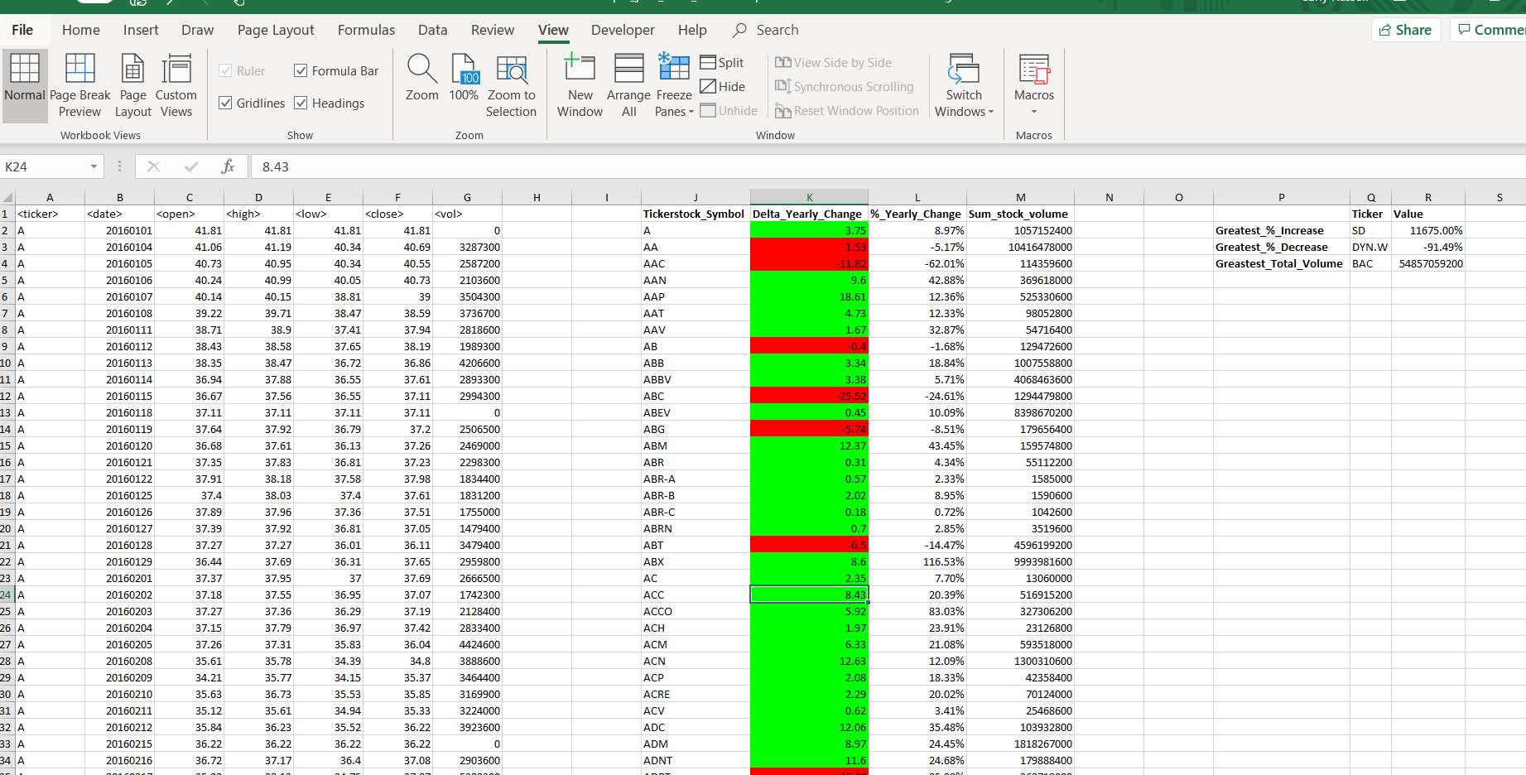

Sheet 2, Year 2015

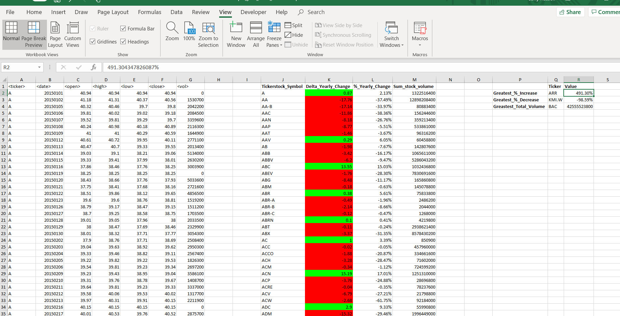

Sheet 3, Year 2014

